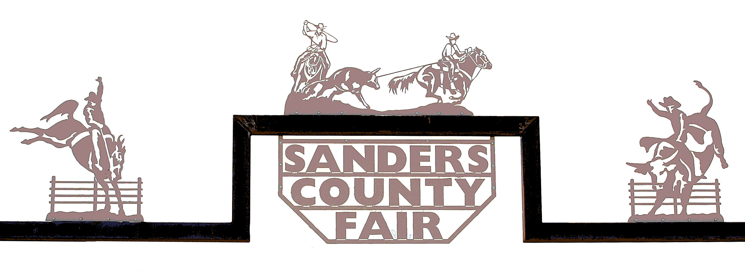

**Sanders County Fair Parade and Rodeo Grand Marshal Nomination Form**

Name of Nominee: _______________________________________________________________________________

Address: ________________________________________ City, State, Zip: __________________________________

Phone: _________________________________________ Email: _________________________________________

Date of Birth: ____________________________________ Date of Death (if applicable) _______________________

**The nominee’s outstanding contributions relating to Sanders County will be taken into consideration.**

* The nominee has made outstanding contributions to Sanders County for any amount of time.
* An individual, business, or organization that has made a significant contribution, in the form of financial or services in kind, to the enhancement of Sanders County.

On a separate piece of paper, clearly indicate the reason(s) you feel the nominee should be considered and how the nominee’s service has made an impact in Sanders County. Nominee may be living or deceased. (Maximum of 2 pages)

**Nominations must be turned into the Fair Office no later than August 1, 2025.**

Person submitting nomination: _______________________________ Phone: ____________________________

Signature: ________________________________________________ Date: _____________________________

Consideration and selection of a new Grand Marshal will be done every year. The Fair Board will oversee the selection process. They will evaluate the candidates and participate in a vote. Selection will be based on exceptional contributions to Sanders County and will be made at the sole discretion of the Sanders County Fair Board.